Collection360 App SOP

The following steps outline the procedure for Collection360 mobile application

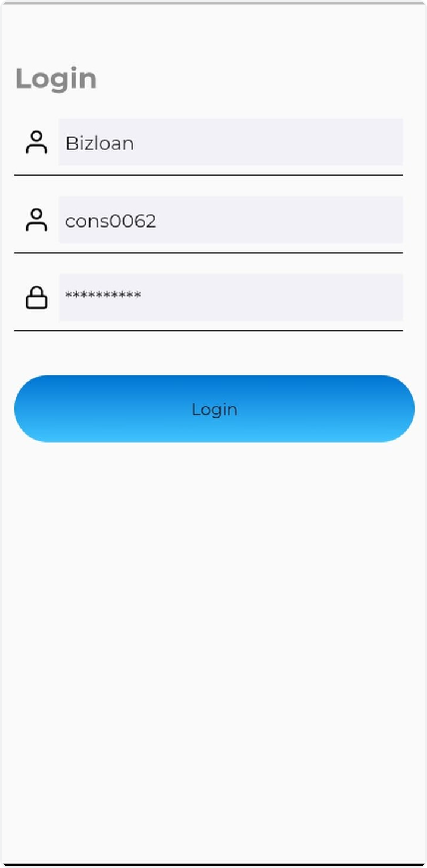

Step 1: Login
- Install the Application: Install the application and grant all relevant permissions.
- Access the Application: Open the application and log in using your credentials.
- Enter Credentials:

- Type your "user ID" and "server name" in lowercase..
- The server name is "Bizloan"

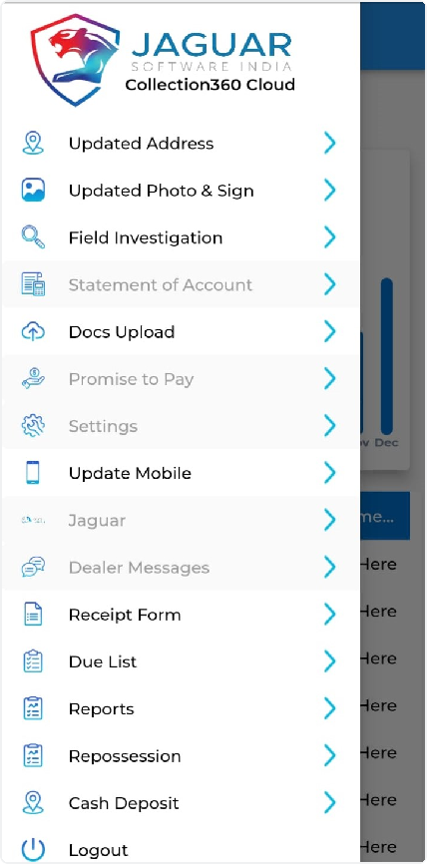

Navbar
The Navbar is the main navigation tool within the application. It contains various links (navlinks) that direct you to diﬀerent sections of the app. However, in this process, we will focus on two key features:

- Cash Deposit: This section is used to record and manage cash deposits.
- Due List: This section allows you to view and manage the list of borrowers with upcoming or overdue payments.

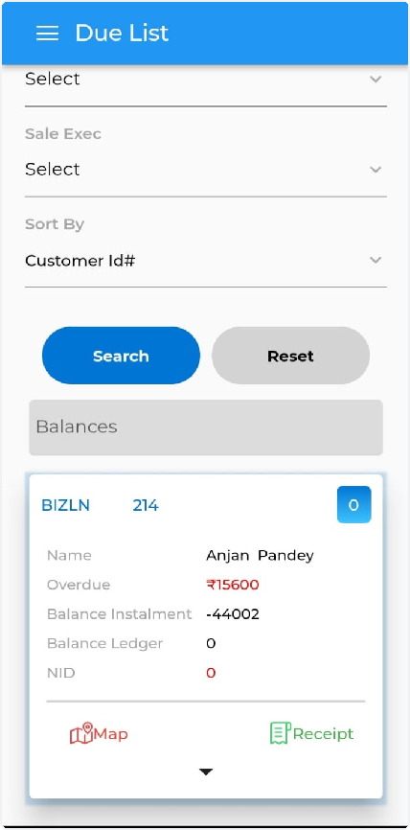

Step 2: Access the Due List
- Navigate to Due List: Go to the due list section inside the navbar.
- View Borrower Details: Here, you can see all the borrower details and their payment due dates.

Search for Due Loans:
- Click the "Search" button to get the list of dues assigned to you
- To search for a speciﬁc loan account, type the loan account number and
click the "Select" button, then click "Search"

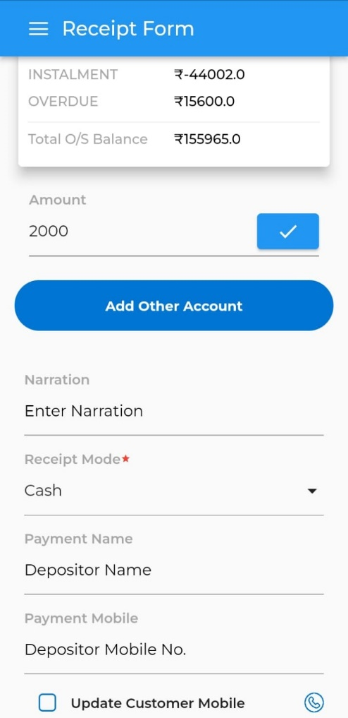

Step 3: Receipt Form
- Open Receipt Form: Go to the receipt form.
- Collect Payment:
  - Enter the amount collected and specify the payment mode (Cash, UPI, or Cheque).
- Click the "Save" button.
- Print Receipt:
- After saving, the "Print" option will appear at the top. Click "Print" to generate the receipt

Share Receipt :
- Go to "Print" -> "Scan" -> "Share" to share the generated receipt for the collected amou

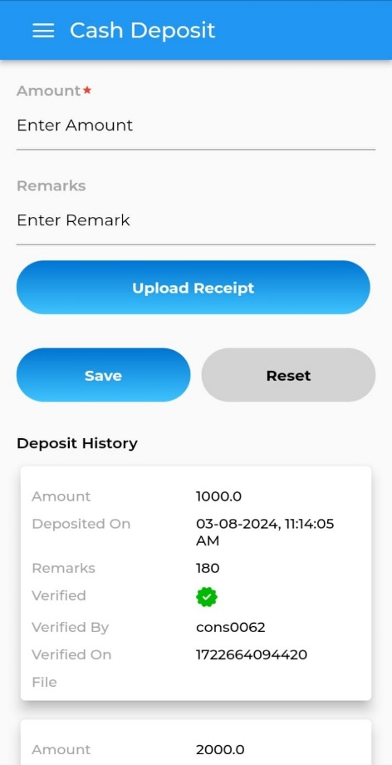
Step 4: Cash Deposit
- Enter Deposit Details:
- Enter the amount you are depositing
- Add a remark if necessary.

- Upload Receipt: Upload the receipt for the cash/amount you deposited in the bank.
- Save Details: Click the “Save” button.

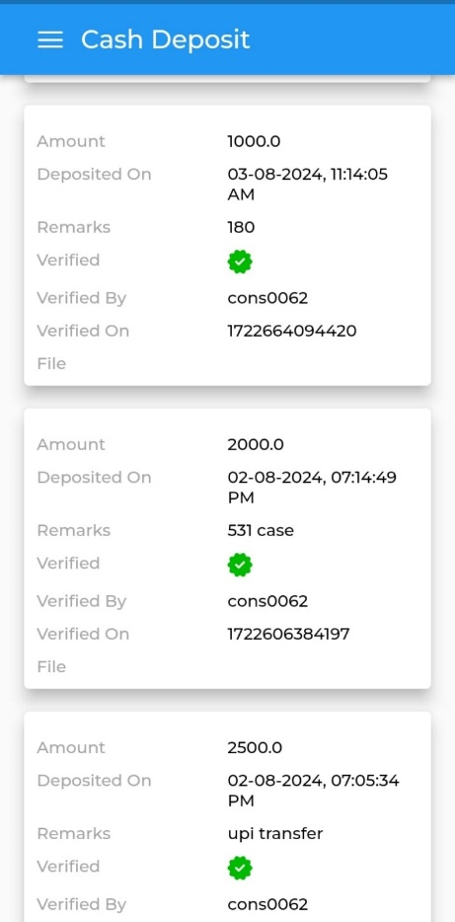
Verification:

Once the deposit is verified, you will see a "Verified" label on your cash deposit area

